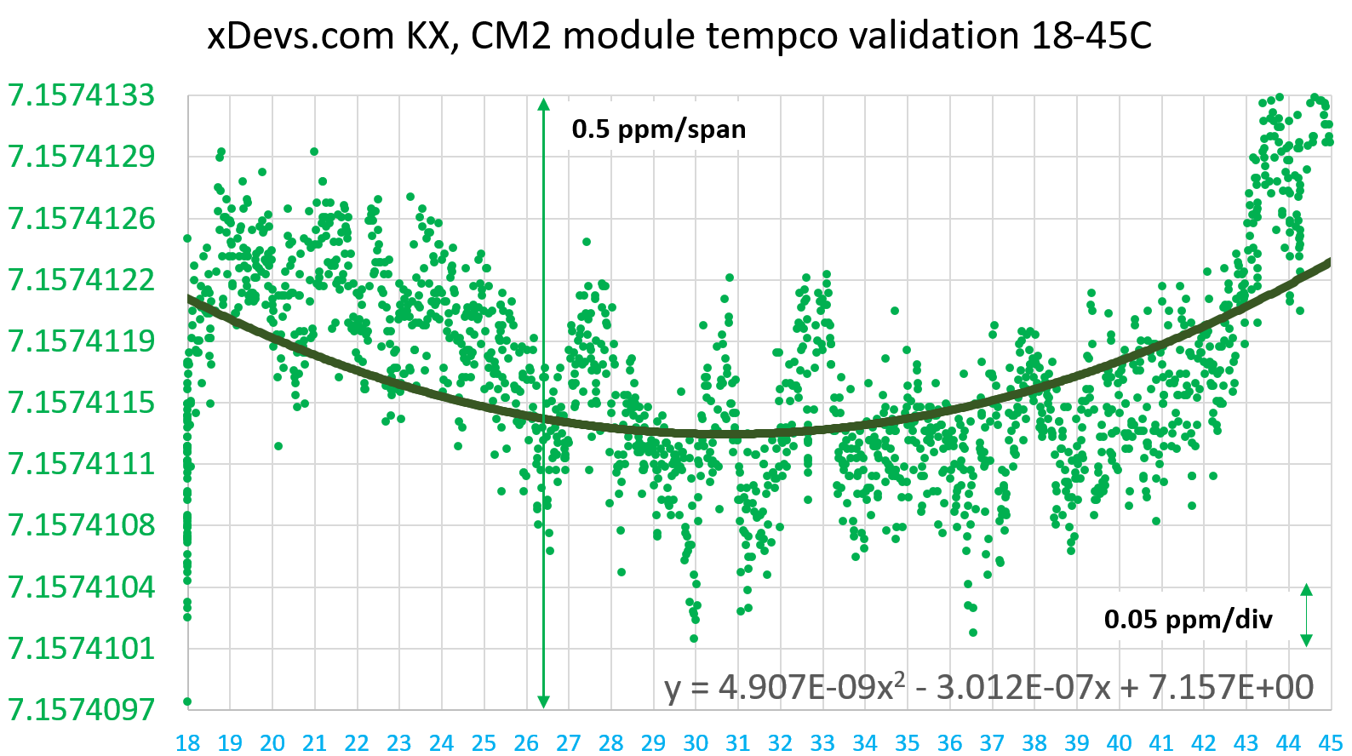

xDevs.com FX DCV

**LTZ1000ACH DC Voltage reference**

**VEMF : 10.000000 VDC *±2.4 ppm***

**α = 0.301E-6 V/°C ; β = 0.005E-6 V/°C**

TCAL : +18.0 °C to +45 °C, RH% : 20% - 50%

Power supply: 2 x +12 6Ah VRLA battery pack

Reference : 2xHP 3458A-X02,APR/06/2018

Δ792X REF : 2.2 µV @ +23.8 °C (K2182)

**CALIBRATION DUE: MAY/20/2018**