The HP 34970A presently has one scanner card, a HP 34901A with 20 Channels as detailed below. Two more scanner cards can be added. Channels are fully isolated.

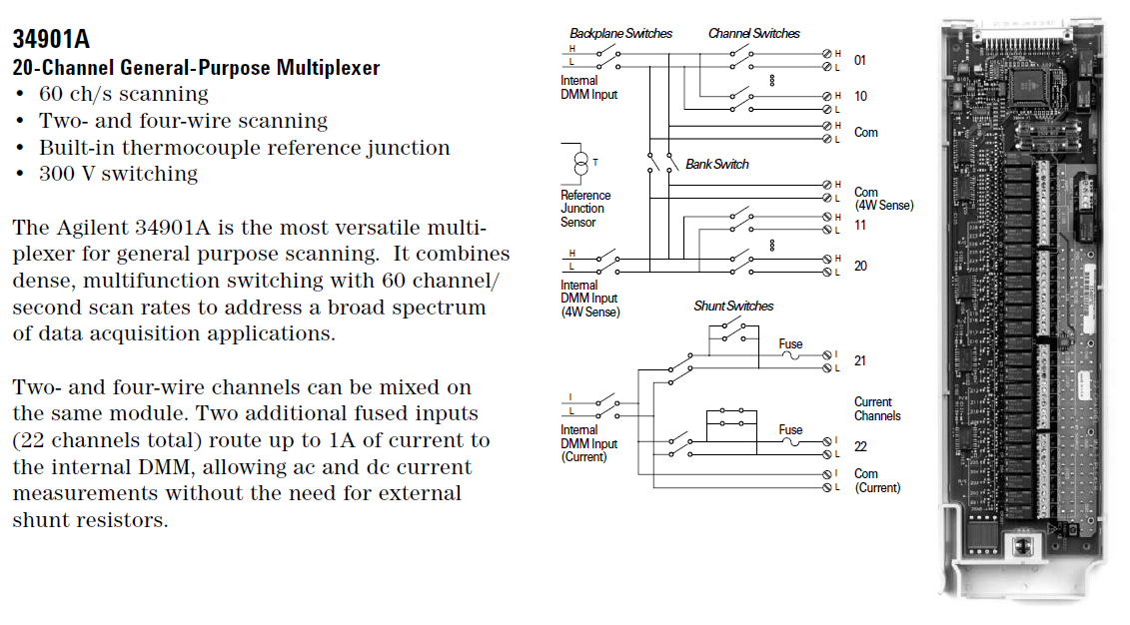

One item to note, with the instrument software, the Data Logger 3 does not scan using a USB-Serial dongle (or at least I couldn't get it to) The Application library will install fine, instrument can be configured in Data Logger 3 but it wanders off when a scan is initiated.

Equipment required:

PC with a real serial port is required, OS can be WIN XP SP3 and up. Ensure that the serial card is setup for 57600 baud 8 bits, 1 Stop bit, no parity, Xon/Xoff flow control.

Null modem cable is with the instrument. If you need to build the one on the right in the diagram:

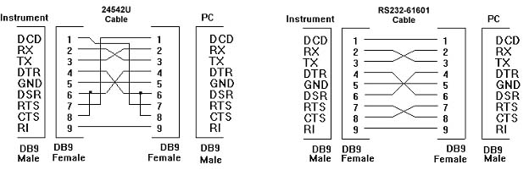

Ensure the HP 34970A is configured for 57600 baud 8 bits, 1 Stop bit, no parity, Xon/Xoff flow control.

Software Installation:

Download the Keysight IO Library.

Current Version:

https://www.keysight.com/main/software.jspx?cc=CA&lc=fre&nid=-33330.977662&id=2175637&pageMode=CV

Previous Versions:

https://www.keysight.com/main/software.jspx?cc=CA&lc=fre&nid=-33330.977662&id=2175637&pageMode=PV

This version worked with XP and WIN7:

IO Library Install:

The Agilent IO Library must be installed then configure the Comm port, detect the HP 34970A and accept.

In this case the COMM Port 1 is VISA interface ASRL1. Set the port fort 115200, 8, 1, NONE, Xon/Xoff. Leave the SRQ line at its default.

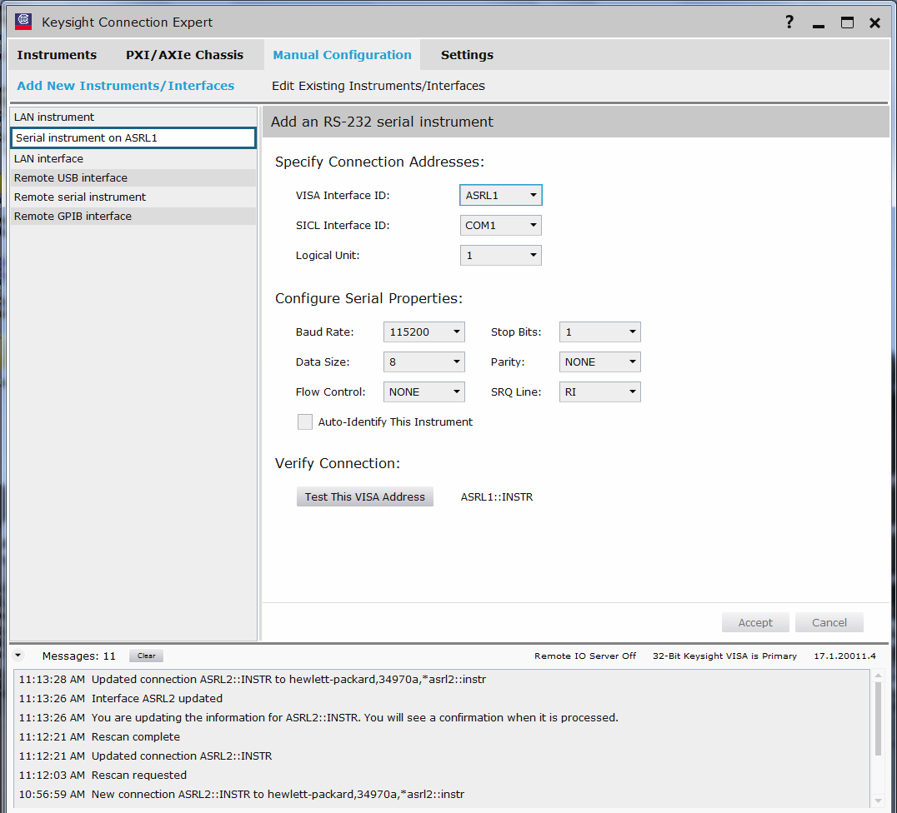

Check Auto-Identify Instrument and press Test this VISA address. It should detect the HP 34970A, click on the accept button.

Now under Instruments the HP 34970A should be present. In this case it is on COM 2 (ASRL2).

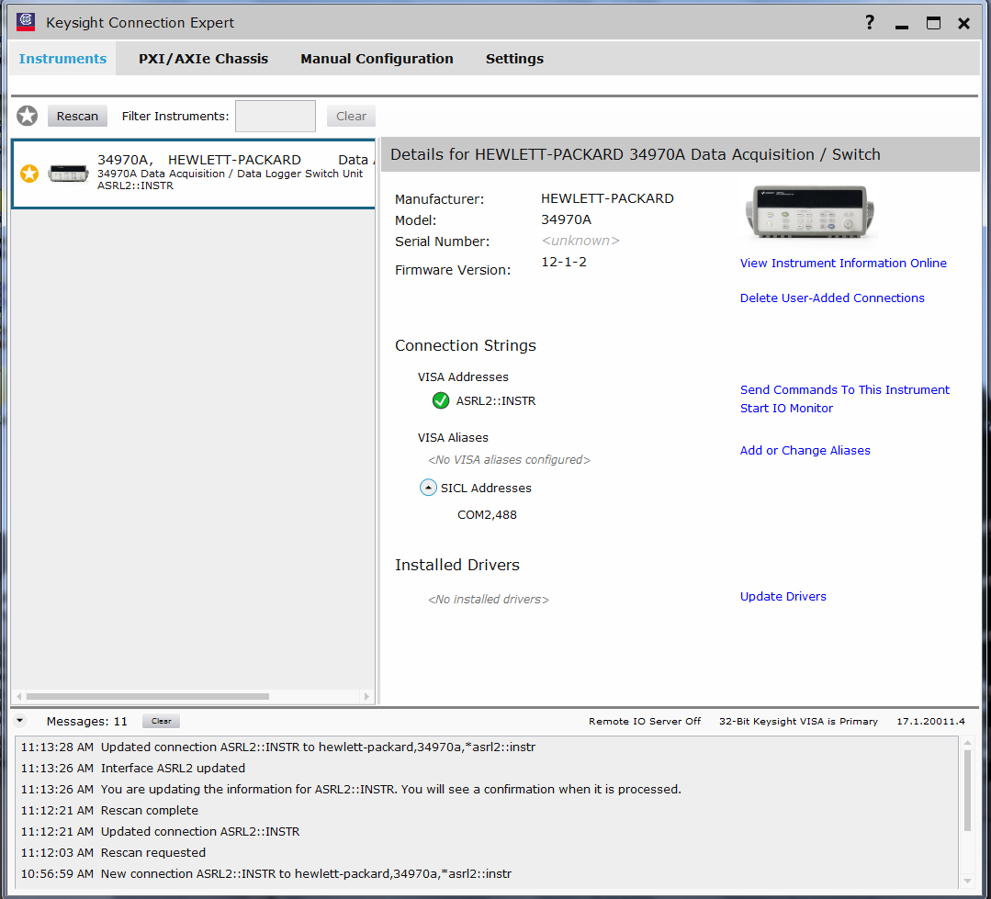

The Data Logger 3 software can now be installed and configured.

Download the Data Logger 3 software:

https://www.keysight.com/main/software.jspx?cc=CA&lc=fre&nid=-11143.0.00&id=sw452&pageMode=CV

Install the software.

Configuration:

Click on the Configuration tab and Select new. Give your configuration a name eg. Temperature 1 and save. The configuration file saves the instrument and scanner configuration.

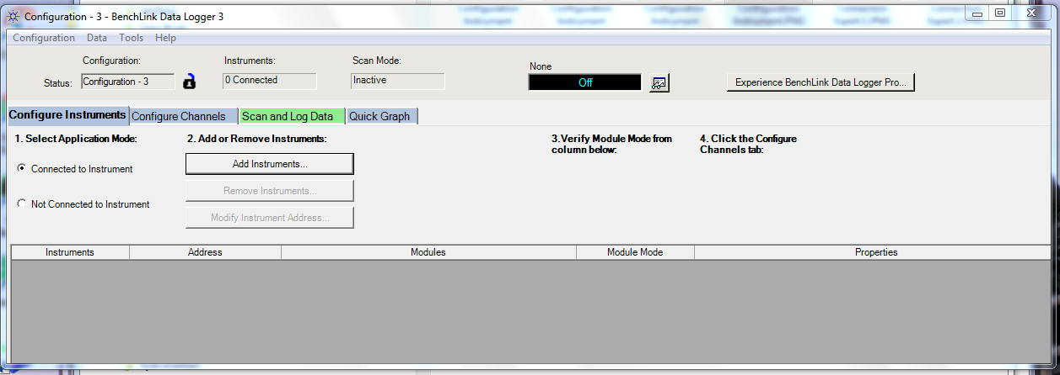

Click on the Add Instrument button, and there should be this dialogue:

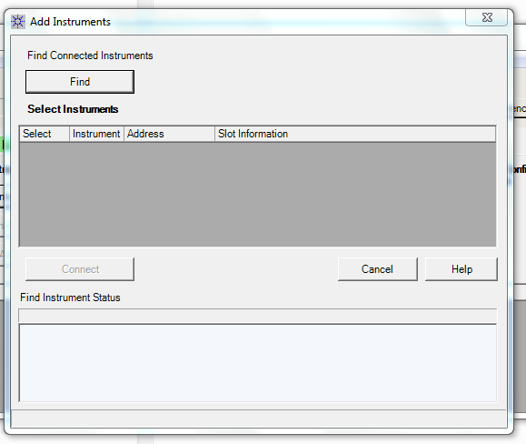

Click on the Find button and check the found instrument then click on Connect:

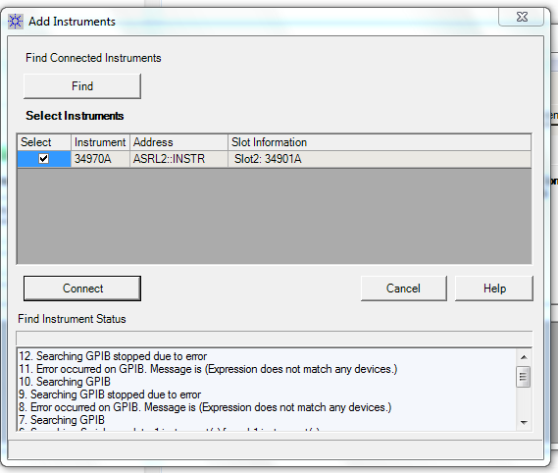

The HP 34970A should now appear in the main window as below, it should show the scanner card that in this case is in Slot 2:

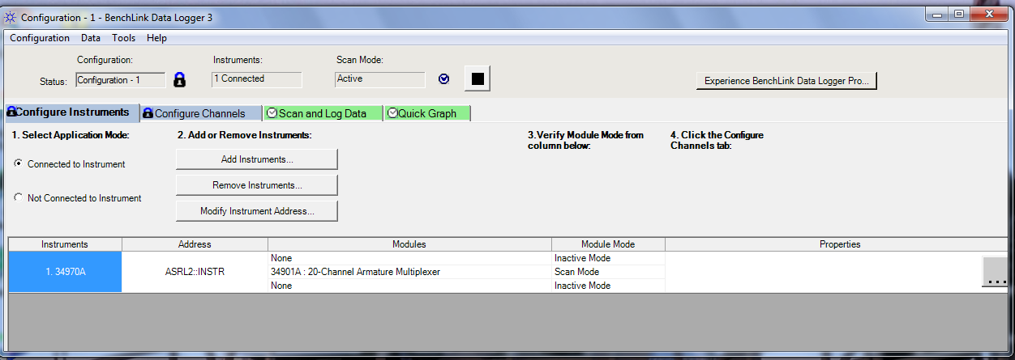

Click on the Configuration Channels tab. The window below should open:

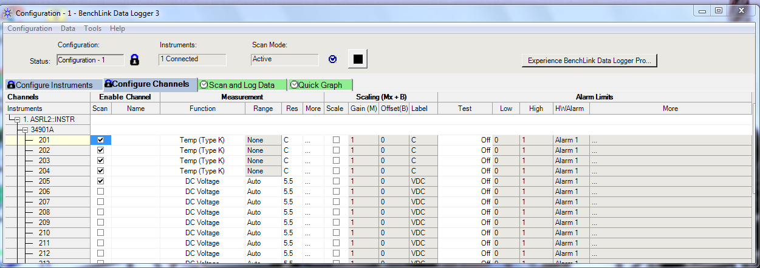

Check the channels you wish to use, then select the measurement type, in this case Chan 201-204 are K-Type T/C, Chan 205 is DC Volts.

Note: The instrument and scanning channel setup is automatically saved to the configuration file.

Clicking on the Data menu, select Data Export Preferences to choose what you export along with checking Export data to CSV on Scan End.

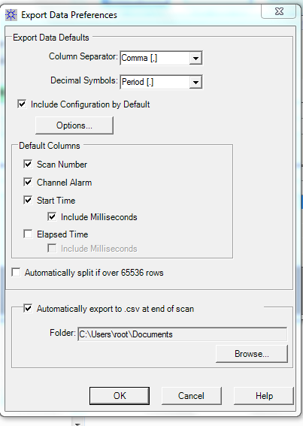

Click on the Scan and Log data tab. The green “PLAY” arrow starts the scanning. You can select one Channel to display using the Monitor window (it says None in image below)

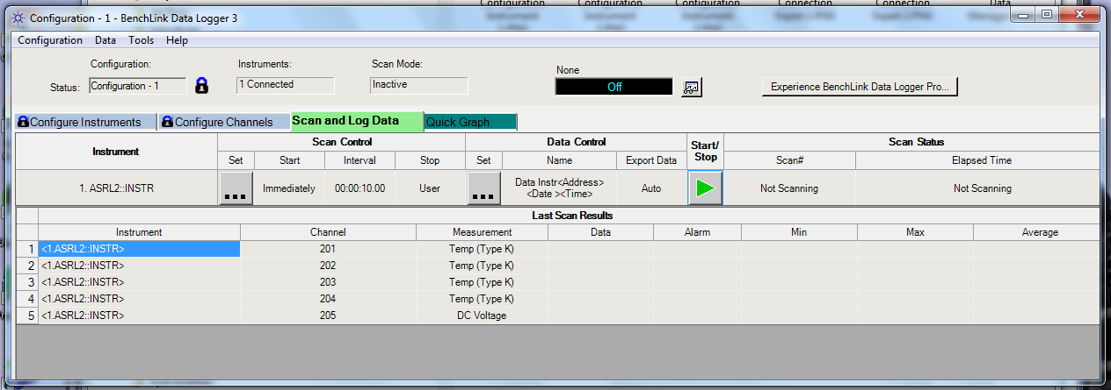

Once scanning has started data will show for each channel along with the selected channel in the monitor window as below. The green PLAY button has now changed to the black STOP button.

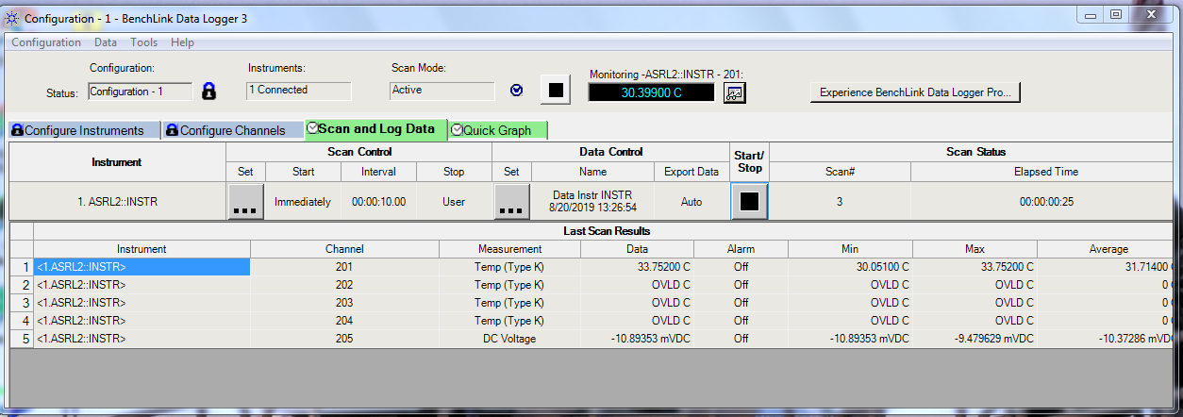

Clicking on the DATA menu item then DATA Manager can be called up allowing editing of the fields.

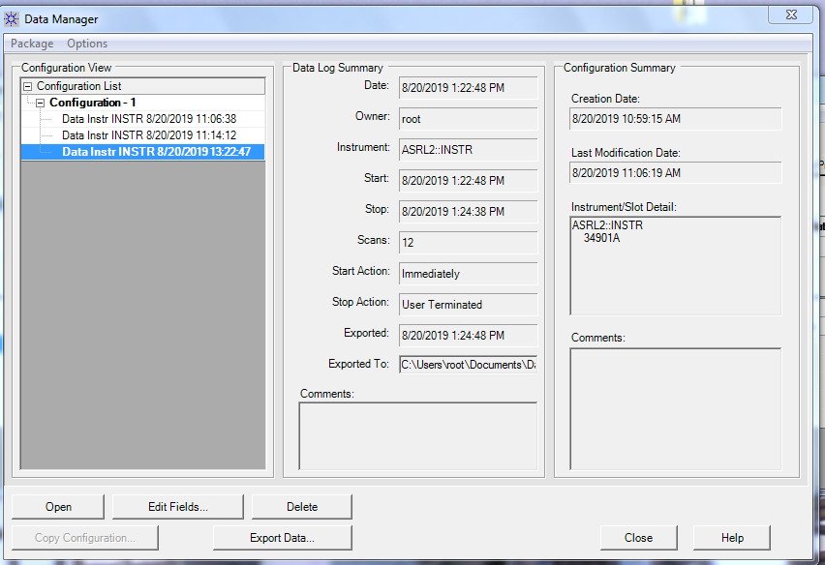

A scan summary can be called up, note at this point while it has been saved inside the program, it has not been exported to a CSV file unless you have checked the box to save to CSV on Scan end.
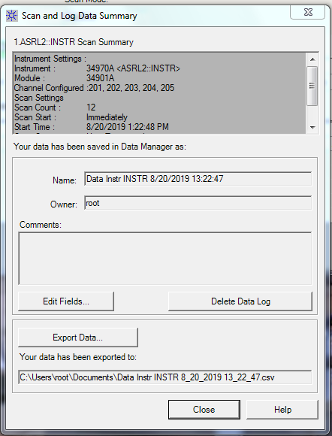
Clicking on an Export Data button will allow exporting the selected session to a CSV file. Any changes to the format can be done at this time.

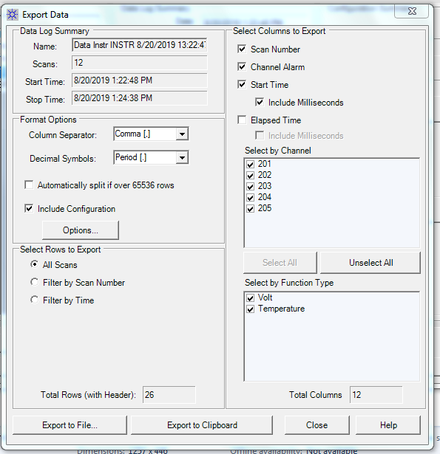

Further automation and scripting can be done through:

Benchvue
https://www.keysight.com/ca/en/software/application-sw/benchvue-software.html#Bundles
https://www.keysight.com/main/editorial.jspx?cc=CA&lc=eng&ckey=2586540&id=2586540&cmpid=zzfindbenchvue_apps

Command Expert
https://www.keysight.com/en/pd-2036130/command-expert?nid=-33002.992473.00&cc=CA&lc=eng

