
ENSURE THE CALIBRATOR IS DISCONNECTED FROM THE MAINS
SUPPLY BEFORE PROCEEDING

1. To gain access to the inside carefully turn over the calibrator and remove the 9 screws located on the underneath of the calibrator.

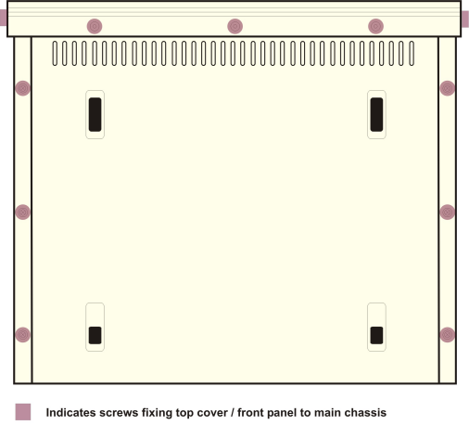
Front Panel side screws require removal to slide cover off enclosure.
Front panel bottom screws only require removal if front panel is to be removed.
Remove all six cover fixing screws to enable cover to be removed.

2. To allow the top cover to be slid back the two side screws must be removed
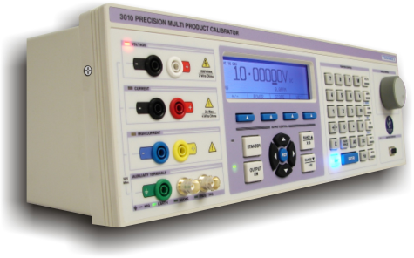

3. Once the screws are removed, turn the calibrator back over and carefully draw the rear panel straight back away from the instrument.

4. Remove the top screening cover.
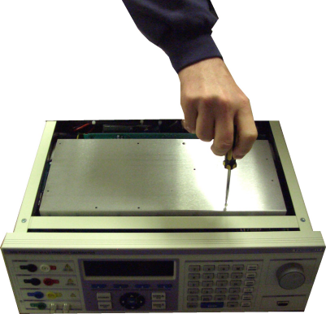

Remove the top screening cover of the PCB – remove all nylon fixing screws, plus 1 metal screw from far end of PCB cover.

5. The Processor is located in the front right hand corner of the Top Board PCB. Note the orientation of the processor and then gently lift the processor straight up. To insert the new processor, line up the pins of the processor with the socket, noting the orientation of the processor and then push the processor into the socket, ensuring that the processor is inserted evenly and all pins are making good contact with the socket.
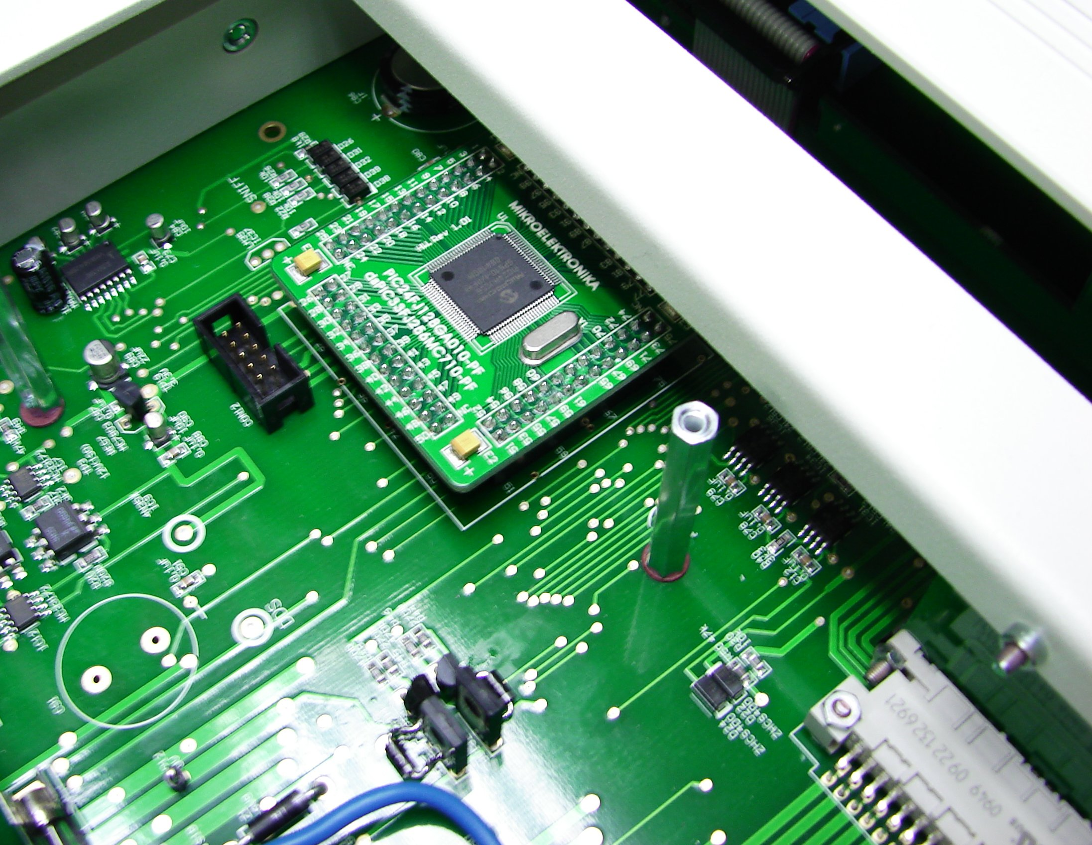

6. After fitting the replacement processor re-assemble the unit by repeating steps 1-4 in reverse, ensuring that all screws are tight.

