Introduction to Trimble GPS Monitor.
The new Trimble GPS Monitor (TGM) application is a tool that can replace many of the previous “monitor” and “chat” programs used for Trimble Embedded and Resolution T products.

The TGM has the features found in the older Trimble applications to configure a GPS receiver as well as improvements in the user interface. It will work with the standard RS 232 serial interface as well as the USB version found in the later starter kits. Instructions for the USB interface are included below.

It has new features such as “Detect Receiver” that will test a GPS receiver port for protocol and baud rate if the user cannot remember, or has lost the settings.

There is a feature to log the output of several GPS devices at the same time, and another to send, and view received raw data.

Some of the basic command steps are listed later on in this document.

Installing the FTDI USB/Serial Driver Software.
  - Confirm that you have the following:

• A PC with Windows Vista, Windows XP Service Pack 2, or Windows 2000 Service Pack 4 installed and a free USB port.

• Internet access to complete the following installation

  - Download the software for your Trimble product as follows:

• Go to the Trimble Support web site http://www.trimble.com/ support.shtml and select the relevant product link and then “Software Tools”.

  - Select and Save all files to a directory on the hard drive.

  - Install the FTDI driver on your PC. The starter kit uses a USB 2.0 dual serial port emulator interface chip from Future Technology Devices International Ltd. (FTDI). In order to use the Monitor software tool to communicate with the GPS receiver, you must first install the FTDI driver on your PC.

  - Use MS Explorer to locate the file called “CDM_Setup.exe” you just saved, and double click it. If properly installed you should see a FTDI CDM Driver Installation popup window with a message that says “FTDI CDM Drivers have been successfully installed”. Click the OK button.

Connect the PC via the USB serial interface.
  - On the PC desktop pass the mouse pointer over the “MyComputer” icon and right hand click.

  - Select the Properties option to view the System Properties Window.

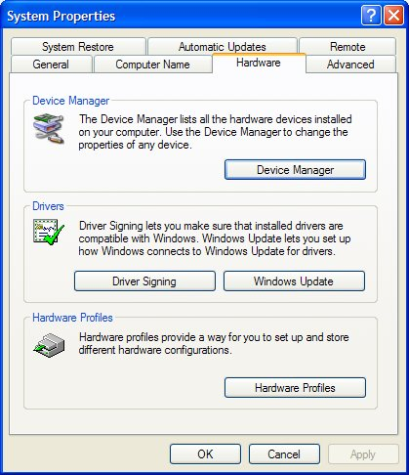

  - Select the Hardware tab.

  - Select the Device Manager button.

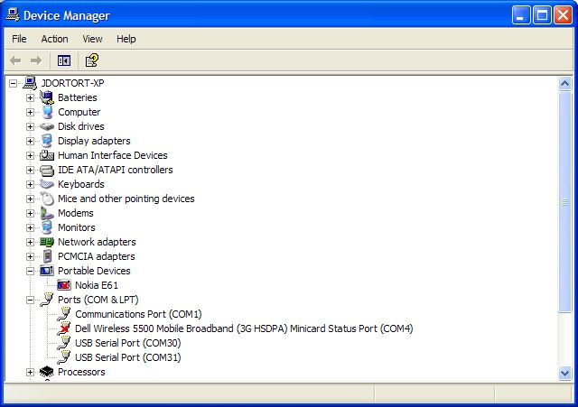

  - Open the Ports (Com & LPT) section and note down the two USB Serial Port COM numbers. In the example above, they are COM30 and COM31.

Note: In general Port A of the GPS device will be on the lower COM number and Port B will be on the higher.

Start the TGM application
  - Go to the directory in which the Trimble GPS Monitor application is stored and double click the icon. The main window will be displayed.

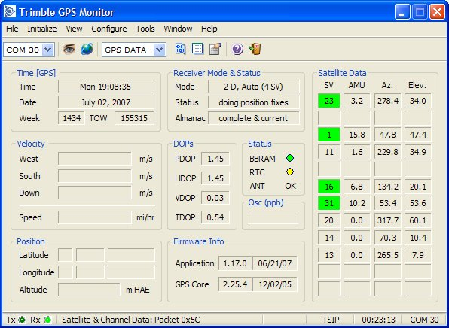

Connect to the GPS Receiver
  - Select Initialize > Detect Receiver

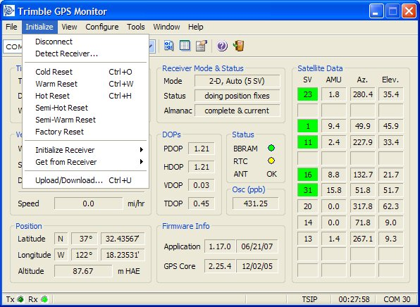

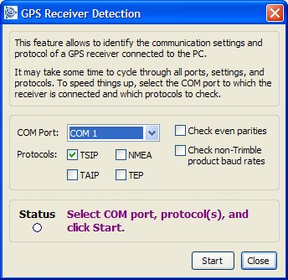

  - Select port and protocol being used on the module.

  - If you do not know which protocol is being used you can select TSIP, TAIP and NMEA. The TGM will try each in turn at different baud rates.

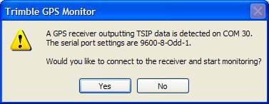

  - Click on Yes to accept the discovered connection parameters.

Configure GPS Ports
  - Select the Configure pull down menu from the main screen.
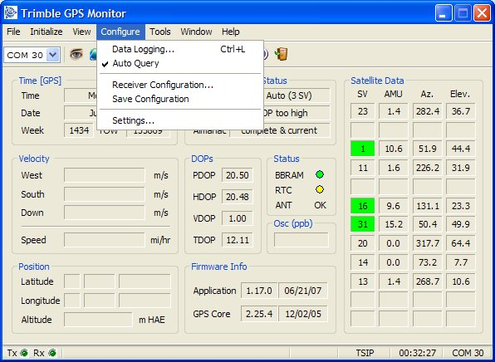
  - Select Receiver Configuration.
  - Select Port Configuration tab.
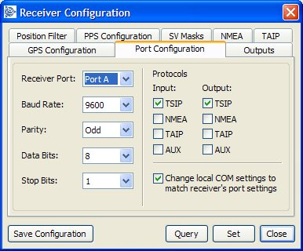

  - Select the required receiver port, baud rate, parity, data bits and stop bits.
  - Select one input and one output protocol.
  - Click the Set button.
  - If the configuration is to be permanent, click Save Configuration.

Configure Output Formats
  - Select the Configure pull down menu from the main screen.

  - Select Receiver Configuration.

  - Select Outputs tab.

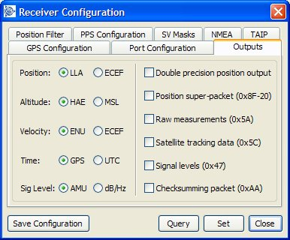

  - After selecting required setup options, click on Set.
  - If the configuration is to be permanent, click Save Configuration.

Configure GPS
  - Select the Configure pull down menu from the main screen.
  - Select Receiver Configuration.
  - Select the GPS Configuration tab.
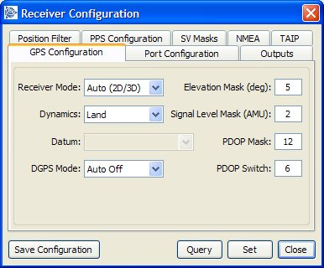
  - After selecting required setup options, click on Set.
  - If the configuration is to be permanent, click Save Configuration.

Configure PPS Output
  - Select the Configure pull down menu from the main screen.
  - Select Receiver Configuration.
  - Select the PPS Configuration tab.
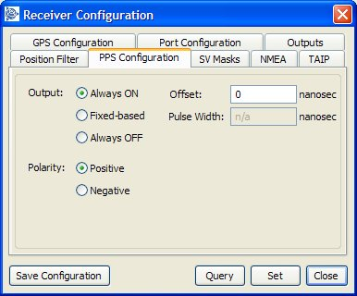
Note: Always ON – the PPS is present even without a GPS fix, it will free run until fix is obtained. Fixed-based – the PPS will only be output when the receiver has a fix.
  - After selecting required setup options, click on Set.
  - If the configuration is to be permanent, click Save Configuration.

Configure NMEA Output
  - Select the Configure pull down menu from the main screen.
  - Select Receiver Configuration.
  - Select the NMEA tab.
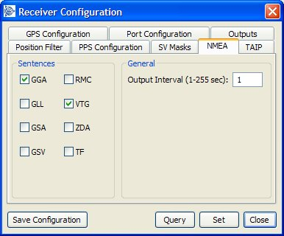

  - After selecting required setup options, click on Set.
  - If the configuration is to be permanent, click Save Configuration.

Configure TAIP Output
  - Select the Configure pull down menu from the main screen.
  - Select Receiver Configuration.
  - Select the TAIP tab.
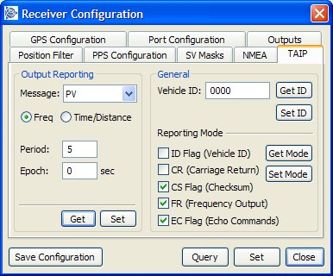
  - After selecting required setup options, click on Set.
  - If the configuration is to be permanent, click Save Configuration.
Note: This screen can only be edited if TAIP is enabled as a port output.

Creating a Log
To log the output of the GPS receiver take the following steps.

  - Select Configure > Data Logging
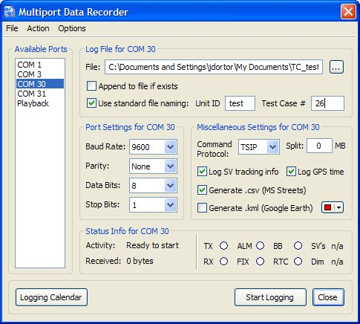

  - From the available ports select the com port that connects to your device.

  - Create a filename and path in the file field.

  - Use standard file naming if appropriate with the Unit ID and Test Case number

  - Select the correct protocol and logging options.

  - Select Start Logging.

Sending Raw Data to device
  - From the Tools Menu select the Generic Packets option.
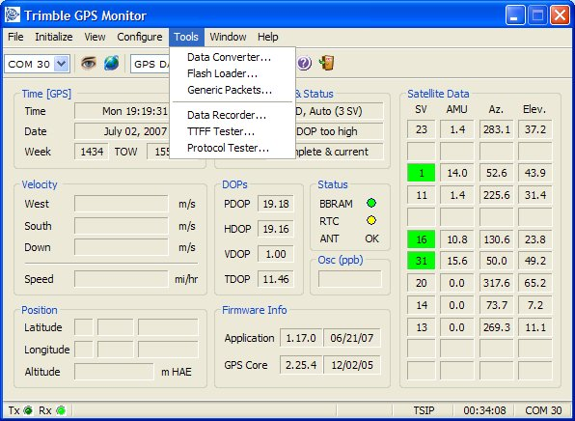

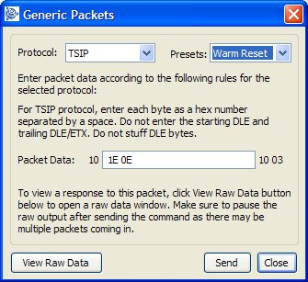

  - Select the required protocol to send the raw data.

  - You can select one of the pre-canned messages from the Presets pull down, or enter your own data in the Packet Data field.

Note: If entering your own message in the Packet Data, the TGM only requires the user data, not the surrounding start and end bytes. In the example above TSIP user data is being entered, but TGM already adds the starting DLE and ending DLE/ETX.

  - Select the View Raw Data button.
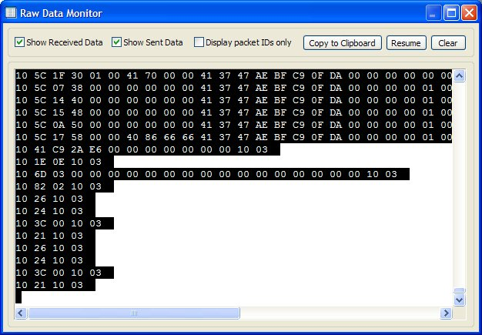

  - To view the sent data as well as the received, select the Show Sent Data box.

