WAVETEK STABILOCK 4031/4032 TEST SETS

The Test Set covers 10Mhz to 999.999Mhz and is controlled by a Host computer assisted by a Slave computer, referenced to a 10Mhz oven controlled crystal oscillator.
Details of the facilities can be found in the operating manual and specification documents. These can be downloaded from the Wavetek user group forum on Yahoo Groups.

The accuracy of the test set is dependant on the 10Mhz crystal reference oscillator which takes approximately 15 minutes to reach an acceptable operating accuracy but should be left for at least 60 minutes for accurate frequency measurements. This assumes that the unit is “In Calibration”.

If the 10Mhz reference is off frequency by only a small amount, the frequency accuracy of the test set will be compromised by varied amounts depending on operating frequency.
i.e. at 10.000Mhz the offset may be 1Hz and at 100Mhz the offset may be 10Hz and at 900Mhz it could be as much as 200Hz.

Calibration by the user can be achieved by comparing the 10Mhz reference output waveform with that of a GPS Disciplined 10Mhz oscillator, or a Rubidium Standard if available. One method is to use the GPS 10Mhz source to trigger the oscilloscope whilst the “Y” input of one channel displays the Test set 10Mhz output.
After a suitable period of time settling down, the test set reference can be adjusted using a trimming tool to alter the frequency set pot on the AF rear module.
The setting procedure should be done carefully over a long period such that the waveform
becomes stationary and stable after a minimum warm up time of 20 mins. In practice, this can take several hours to achieve the best result. As time goes on, the oscillator accuracy will drift very slowly and so the calibration procedure should be repeated at regular intervals, generally every 12 months.

After many years of use and abuse! these sets may display various fault symptoms, common problems include no output or unlocked output from the generator, inaccurate
measurements, no functions or selected functions only working, no power up, display problems, burnt out attenuator sections due to misuse (very easy to do!).

The Test Set has a Self Check function at Power up. In the event of problems, the self check does not complete without failures of one or more units. Whilst this can be useful, it has been found that the failure of one sub unit can lead to the apparent failure of others.
The only satisfactory situation is the message “Self Check Passed OK”. The Holy Grail.

Stabilock models 4031 and 4032 are very similar and in general can be treated as the same. Various “Options” may be fitted.

Probably the most common problem is the wholesale failure of electrolytic capacitors.
The set has approximately 70 small form factor aluminium can electrolytics with a value of 10uF 16V with Surface Mounting tabs. RS COMPS: Stock No: 727 1000
Without exception EVERY ONE of these should be changed!

These capacitors dry out and or leak electrolyte over the PCB and if left too long, cause corrosion and destruction of the very fine tracks on the boards. It is necessary to remove the faulty ones with great care!. Inevitably some track damage will result in some cases.
It is recommended that the PCB lands are desoldered and cleaned thoroughly. Corrosion can be carefully scraped off and a non corrosive flux used to re-tin the lands before placing the new capacitors on the board. The board area should be cleaned with Isopropyl Alcohol or similar to remove traces of flux after completion.

The test set also contains similar capacitors of higher value (47uF.100uF,220uF 470uF)
but the quantities are only small in comparison with the 10uF caps. It is always useful to replace these but unless there is evidence of leaking electrolyte, visual indication of furry deposits on the PCB lands, then a capacitance check can sometimes be done in circuit to verify the component in question. However, the performance of the test set may be impaired if some of these larger capacitors are left in circuit, their ESR may have increased and the effectiveness of the capacitor may be reduced.
If possible replace them all!

Recommended approach to repairing the 4031/4032.

If the test set powers up and goes through the self check routine with some failures then the power supply rail voltages should first be verified.
The power supply produces +15v -15v & +5v.
The most convenient place to measure these rails is on the RF Backplane PCB.
Remove Top Cover, remove Aluminium Cover to reveal the underside of the RF Backplane PCB.

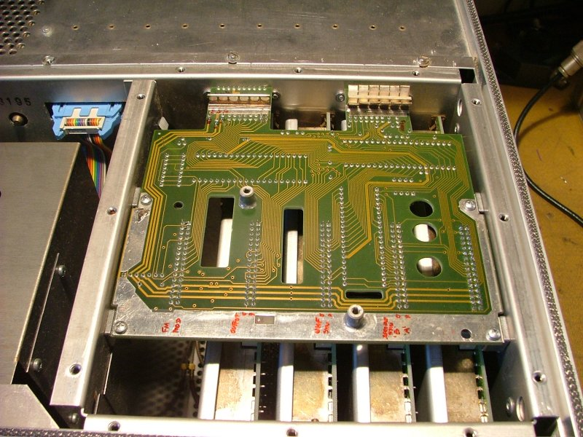

At the top left of the PCB there will be a supply connector with the three rail voltages on thick tracks running down the left side and along the bottom of the PCB.

The +_ 15volts and the +5volt rails can be measured carefully to avoid any short circuits, on the connector pin ends of the tracks.

From left to Right. +5V +15V -15V

If any of these voltages is missing or more than 0.5 volt out then the PSU needs investigating.

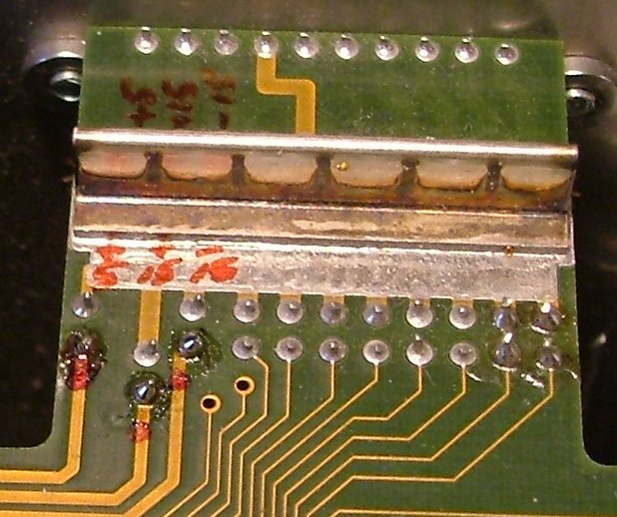

Assuming the +-15 and +5 rails are good then detailed diagnosis will require the use of extender cards to enable the RF modules and the IF/AF modules on the back of the set to be operated and observed without covers on. In the RF units, there are small red LED’s on the boards that indicate the status of various PLO’s etc.

However, experience so far suggests that you simply remove each module individually, Inspect / Clean corrosion / Repair broken tracks / Replace the Capacitors. I always check the test set status before and after working on any module. That way you can keep track of what you have done. The last thing you need is confusion!

The Service Manual for the 4031 is available to download in 13 files from the Wavetek Yahoo Group. I found it convenient to print relevant pages for general work on a unit but use the .pdf file for component locations and values. The overall test set layout diagram is worth printing and sticking together, it takes about 12 A4 sheets which can be pinned up for easy reference. The operation of the set is easier to understand with this large drawing.

SUMMARY OF FAULTS FOUND to date.

There are around 70 10uF16V electrolytic capacitors spread around the various units and it is worthwhile replacing every one. Many will look OK when tested "in-circuit" but you can be fooled. Look very carefully for signs of corrosion on the solder tabs, they tend to look grey and furry! Before I got fed up with the monotony of testing each one out of circuit, most were open circuit, I opted for wholesale replacement of all of them. The only units exempt are the Host and Slave Computer boards.

Some of the 100uF and 47uF capacitors were found to be leaking electrolyte and needed to be changed.

The Power supply can be troublesome, there are two boards that are linked together, the interconnections need to be checked. If you are taking the PSU to bits, consider fitting rear panel LED’s to display the +-15 and +5 rails this can save a lot of time.

See separate faulting notes for the SMG4032 PSU.

The RF Attenuator unit is an electro-mechanical device with DC solenoids operating spring loaded sliding studs across a gold plated PCB. The attenuator sections are made up of Thin Film units that are soldered onto the PCB. It is common for the input 20db section to burn out if RF is fed into the RF DIRECT (TNC) port on the front panel. See warning Label.

Replacement Thin Film attenuators are only available if you order around £500 worth and so an alternative repair has proved to be satisfactory. The use of close tolerance surface mount resistors of appropriate wattage and size may be soldered to the board in place of the thin film section. It is tricky but can be done with care. The values
to make up a 20db T section are: 39.0 + 39.0 ohms with a 10.0 ohm shunt resistor.
These are preferred values which give an attenuation of 19.73db with a VSWR of 1.04:1.
This seems to be satisfactory for most applications.
The FM Modulator RF Unit contains a 56 – 76Mhz oscillator which is part of the Fine Decade. The VCO chip was found to be temperature sensitive and would unlock when cold. The MC1648P was replaced to cure the problem.

Various broken or corroded tracks have been repaired.

In one case, there was no output below 125Mhz. This was found to be a corroded track supplying power to the SAW Oscillator in the Output Unit.

The Keypad can give trouble due to dirty/well used keys.

If the Frequency Counter function does not work at all, suspect capacitors in the RF Detector module. This is hard to get at and requires some dismantling of the set!

If the Frequency Counter Function in RF TX mode shows an "Offset" when it should be 0.00Hz then the 8Mhz clock chip may be faulty in the derived clock sub board, located on the AF Detector Unit. In my case, the 74LS290N divider chip was faulty and dividing by 4 instead of by 5 resulting in a 7.5Mhz clock signal instead of 8Mhz.

If the Self Check Pass function cannot be obtained after all the work has been done, check the functionality of the Multiplex decoding chips in the AF Detector Unit.
ALL test functions rely on the test values from various detectors in the test set to be fed back to the Slave computer Unit for analysis and graphic presentation on the various screens or templates. The AF unit collects these test signal results which are fed back to the Slave computer on a Multiplexed Bus. In one case it was found that the Bus was not being addressed by the Slave due to a faulty 4:16 decoder chip MC14514 on the AF Detector board. It was mainly by luck and generally poking around for clues that the lack of a strobe signal was noticed! A Logic Probe is useful to verify each chip functions.

The Monitor is generally fairly reliable but if the Raster is jittery then it pays to replace the Electrolytic capacitors in the monitor unit. Also check for high value resistors that may have increased in value! A garbled screen can indicate out of lock horizontal timebase, which may just need a readjustment. If lock is at one end of the pot, look for out of tolerance resistors around the horizontal timebase.

Be careful as hazardous voltages are present in the Monitor Unit!!!

Pictures of Homemade Outrigger extender cards:

Extender cards made from modified IDE cables and connectors.
They are not pretty but do the job!

The connectors are 32 pin in 2 rows of 16. A computer Floppy Drive IDE connector is 34 pins in 2 rows of 17. These can be cut down to 32 pins for both the IDE cable female ends and also for recovered male connectors from scrapped floppy drives.

RF UNIT Extender Card.

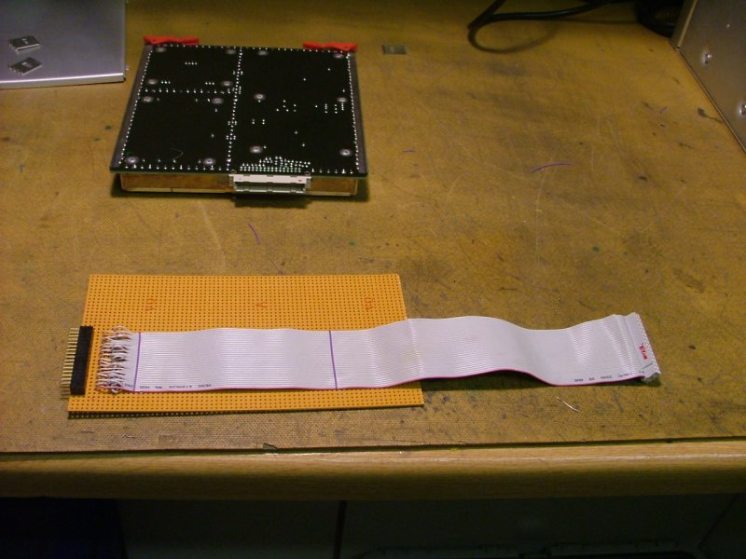

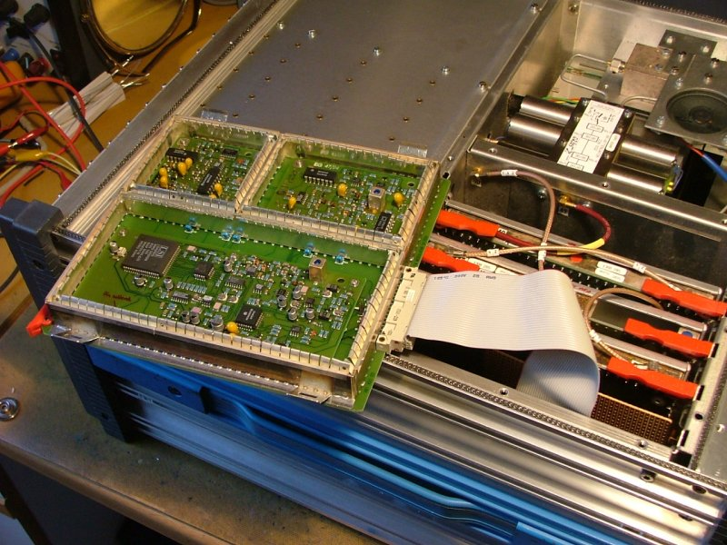

RF
UNIT on Extender card.

IF/AF UNIT EXTENDER CARD

The IF/AF cards are 64 pin and require 2x 32 pin cut down Floppy connectors glued side by side onto a Veroboard sheet.
The same is required for the male connectors which are cut down recovered connectors from scrapped drives.

The Veroboard mounted IDE pins can be mounted on a large Paxolin sheet cut to the same dimensions as a typical slide in IF/AF card. Note the cut out to allow it to fit in the frame.
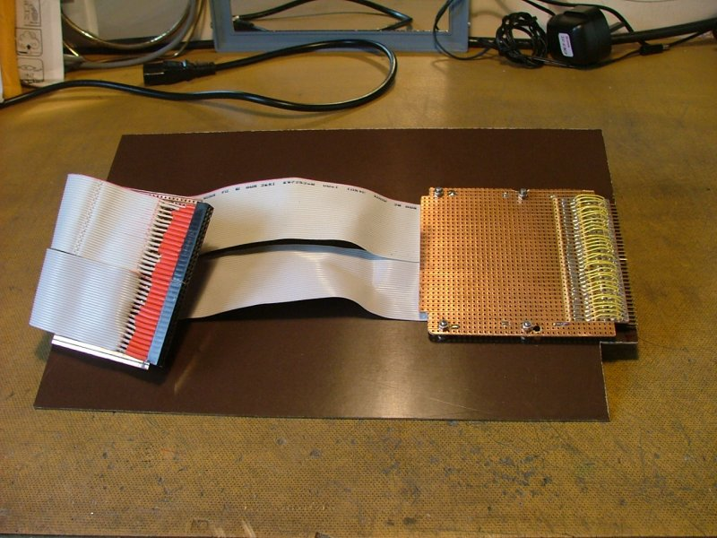

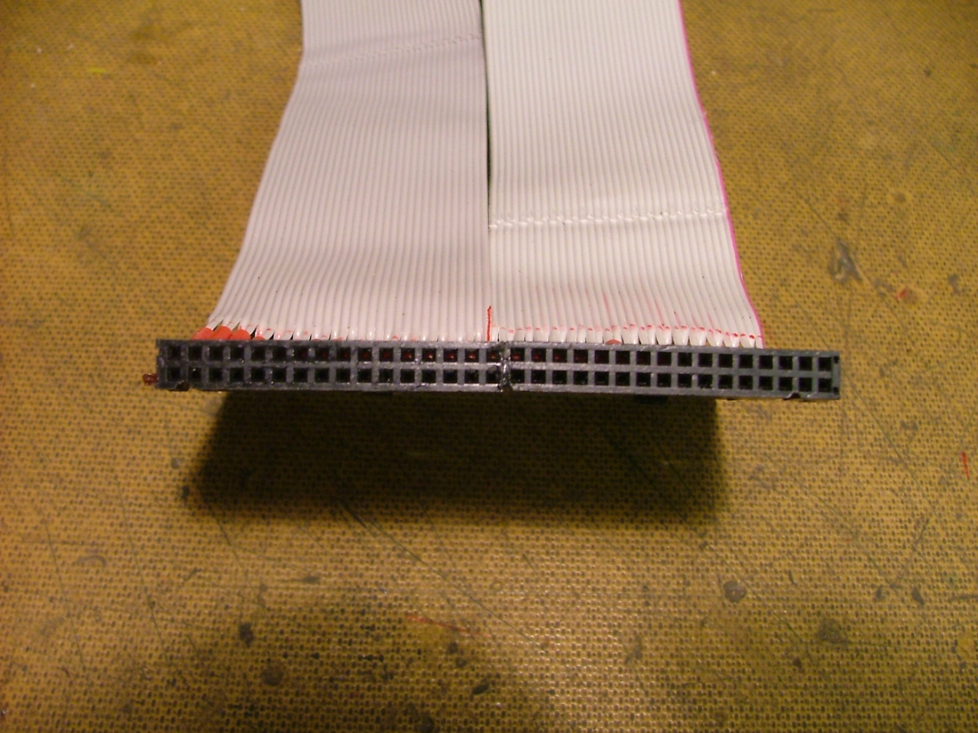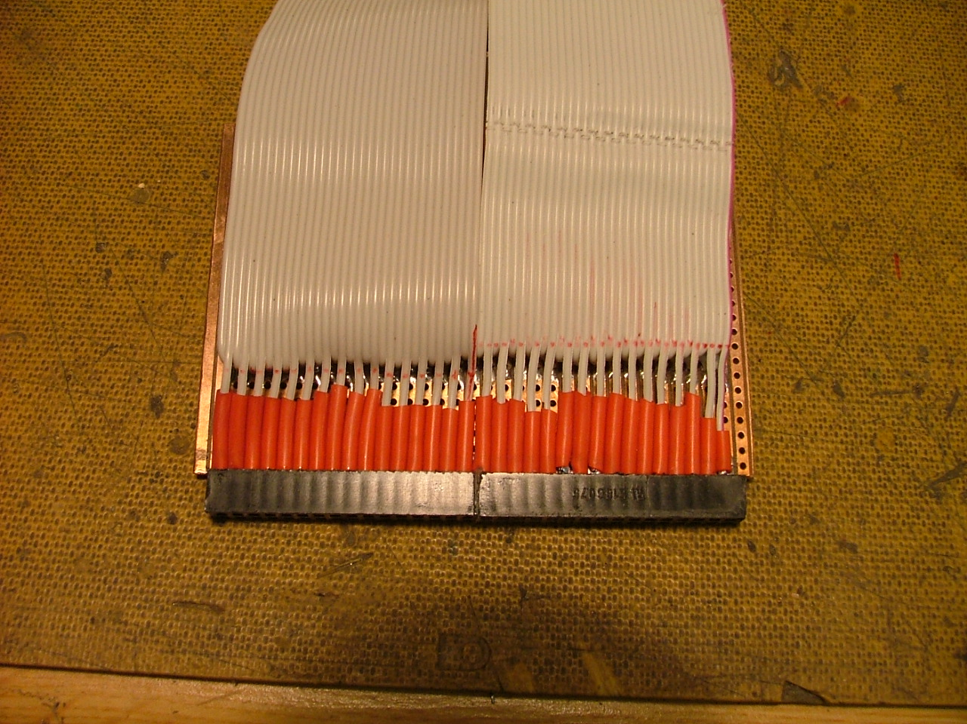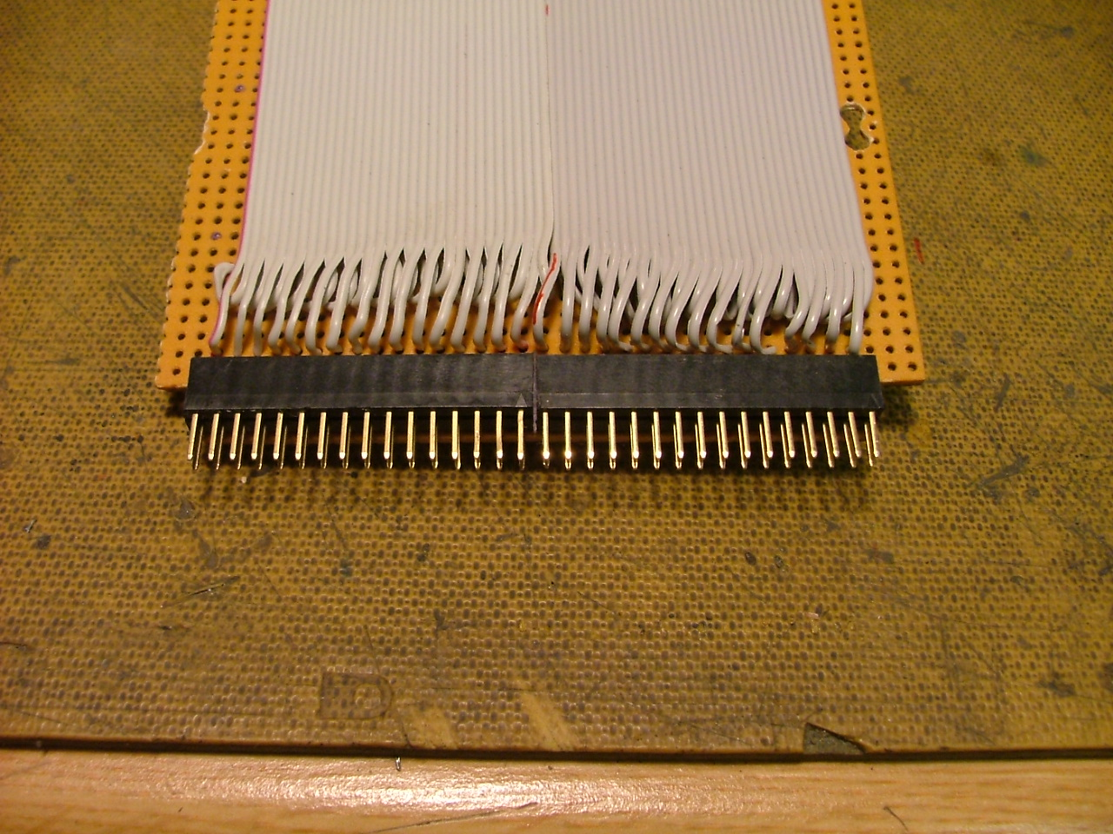

AF Detector Board on extender card.

Note the lower part of this unit houses the 10Mhz Oven controlled ref osc.

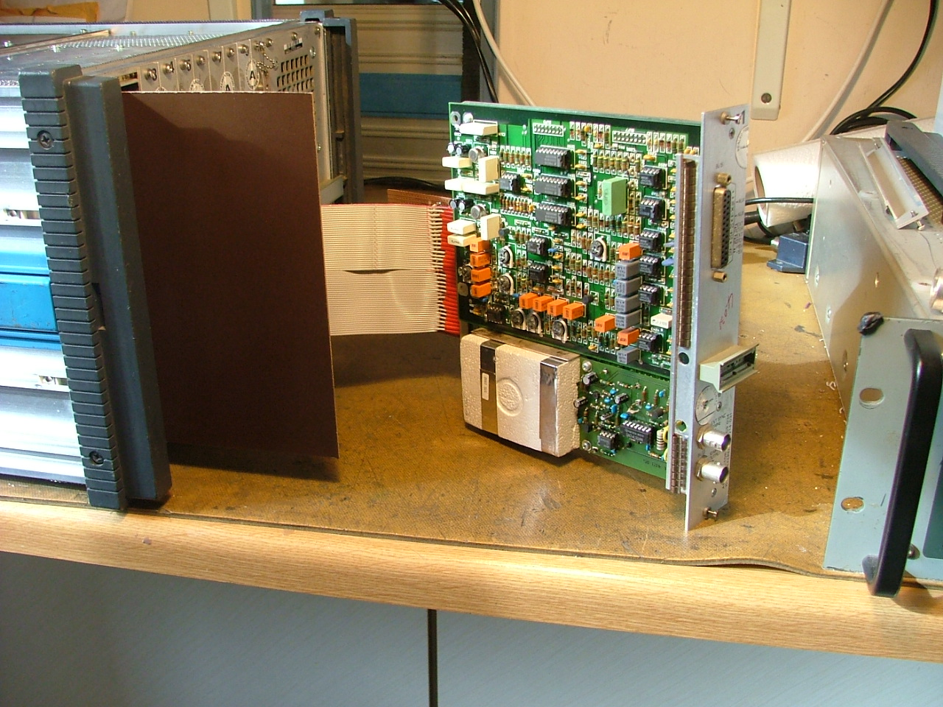

I have a few more pictures if anyone needs them.

Paul Kelly
G3SDH
g3sdh@btinternet.com
.

